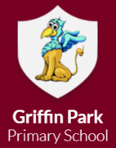

Year 2

Summer Term 1 2026

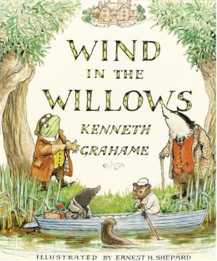

Glossary
Below are the key words your child will be using in class this half term.
Please help your child to complete the glossary and be able to use and spell the words.
Please feel free to add any additional topic related vocabulary that you can think of.

Word | Definition
River Thames
Monument
Catastrophe
Equality
Racism
Climate
Extreme

Over the next half term, your child will be
Working on:
Science week – life cycles
Narrative: The Wind in the Willows
Dairy of The Great Fire of London and a report on plants.
Measuring, mass, volume and capacity and time
Learning about animals and plants in their natural habitats. Growing plants and eating healthy.
Looking at the moving vehicles in DT.
Learning about the Northern Territory and extreme weathers.

Your child needs your help and involvement! Please get involved by:
• Discussing the new vocabulary with your child.
• Regularly practising times tables. (Children receive a badge and certificate when they remember a set of times table facts e.g. 2 times table and division facts)
• Regularly practising spellings
• Encouraging your child to do some reading for at least 5 minutes every day, independently or to an adult.
Routines
PE: Indoor PE will take place on a Tuesday and indoor PE will be on Friday.

Homework
Reading | Try to listen to you child read a little each day. Books will be changed every Monday, Wednesday and Friday. Please remember to sign diaries.
Homework log | Complete homework in green homework log book to earn house points and tickets. These will need to be returned on Thursday, for new homework tasks to be given again on Friday.
Spellings/maths facts | Spellings/maths facts will be sent home on Friday and children will be tested the following Friday. Please remember to return spellings/maths facts book for new ones to be stuck in.
Library | Library books will be changed every Tuesday.

Dates for the Diary

Science Week | 13th April
Bank holiday | 4th May
Year 2 school trip to Martin Mere | 15th May
School closes for half term | 22nd May

