

**Nursery**

**Autumn term 2**

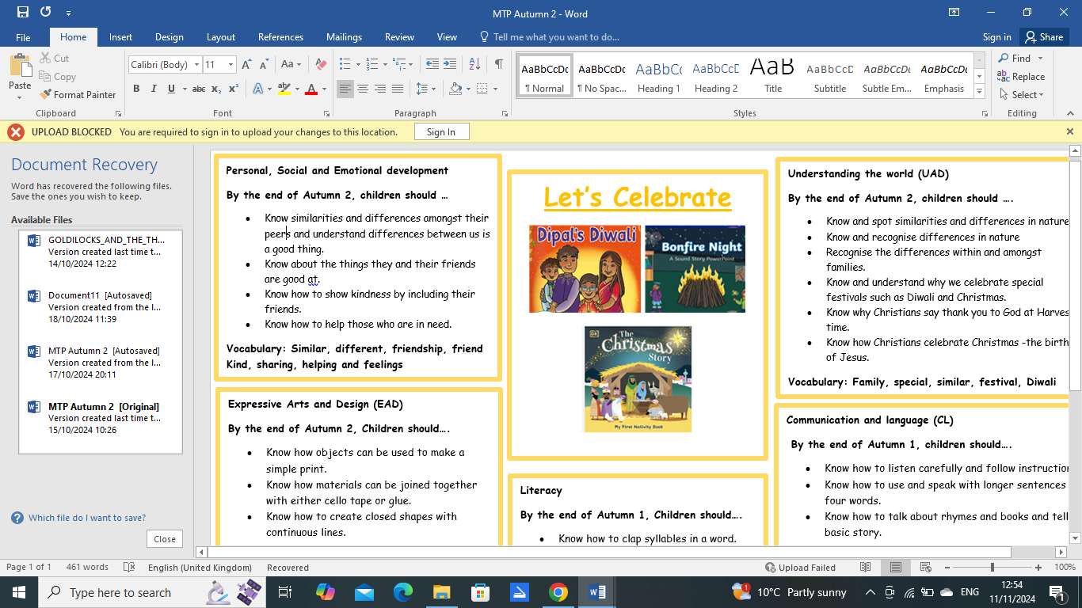

**I hope you all had a lovely half term. Nursery Children have all settled in really well.**

This letter is to inform you of some of the things we will be learning in Nursery this half term. We will be learning about **Celebrations**! We will be using these keywords throughout this half term.

|  |  |  |
| --- | --- | --- |
| **Similar** | **different** | **friendship** |
| **friend** | **Kind** | **sharing** |
| **helping** | **feelings** | **similar** |
| **special** | **Family** | **Christmas** |
| **festival** | **Diwali** | **Bonfire night** |
| **Remembrance day** | **Celebration** | **Baby Jesus** |

Mrs Thompson teaches Monday afternoons and Tuesday mornings. I will still teach throughout the week. If you have a query or want to discuss any matters, just let me know and I will answer any questions you may have or arrange a time to discuss this further.

**Drop-off and Collection**

Morning sessions starts at 8:45 am and finishes at 11.45 am. Afternoon sessions start at 12:15 pm and finish at 3:00 pm. Please can you make sure your child is being picked up on time. Please let me know if another family member or friend is picking your child up that day.

**Clothing**

Please could you place a set of spare clothes, shoes and socks in your child’s bag every day, as the children may have accidents. The children will be encouraged to change into their dry clothes with support from the staff. We would ask that all items of clothing, coats and jumpers are labelled clearly with your child’s name.

**Class Topic**

Our topic this half term is “let’s celebrate”. In this topic, the children will be learning about all celebrations and festivals that take place. This includes Halloween, Bonfire night, Diwali and Christmas. We will be learning about the birth of Jesus and the special events that took place. We will be doing many more fun activities for the children and we cannot wait to get started!

**PE**

PE will take place every Monday afternoons and Tuesday morning. For the near future, PE will only take place indoors. Please could your child come to school already dressed in joggers/leggings, T-shirt, trainers.

**School Website**

Please visit our class page regularly. I will post regular photos and videos in order to share all the great experiences we are having in Nursery.

I hope that this answers any questions you have. If there are any further queries, please do not hesitate to contact me.

Thank you so much.

Miss Survery