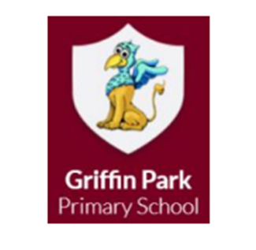

**Nursery**

**Spring term 1**

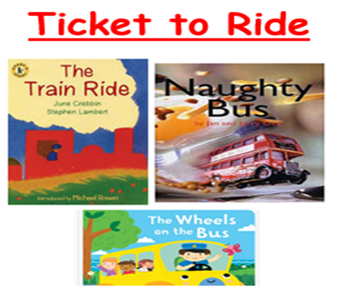

**I hope you all had a lovely Christmas break. Happy New Year and welcome to Spring Term 1! We will be welcoming some new children into our class this term.**

We will be using these keywords throughout this half term.

|  |  |  |
| --- | --- | --- |
| **safe** | **safety** | **signs** |
| **playground** | **clothing** | **weather** |
| **pavement** | **train** | **bus** |
| **careful** | **Vehicle** | **cars** |
| **taxi** | **places** | **past** |
| **environment** | **roads** | **train tracks** |

Mrs Hardy teaches Monday mornings. I will still teach throughout the week. If you have a query or want to discuss any matters, just let me know and I will answer any questions you may have or arrange a time to discuss this further.

**Class Topic**

Our topic this half term is “ticket to ride”. In this topic, the children will be learning all about vehicles! This includes bus, trains, cars etc. We will be reading lots of exciting books about them! We will be doing many more activities that are fun for the children and we cannot wait to get started!

**Tapestry**

Please remember to check Tapestry regularly for reminders of important things. I also post regular photos and videos of the children so please make sure you check your Tapestry accounts.

**Clothing**

Please could you place a set of spare clothes, shoes and socks in your child’s bag every day, as the children may have accidents. We would ask that all items of clothing, coats and jumpers are labelled clearly with your child’s name.

**PE**

PE will take place every Monday afternoons and Tuesday morning. For the near future, PE will only take place indoors. Please could your child come to school already dressed in joggers/leggings, T-shirt, trainers.

**School Website**

Please visit our class page regularly. I will post regular photos and videos in order to share all the great experiences we are having in Nursery.

I hope that this answers any questions you have. If there are any further queries, please do not hesitate to contact me.

Thank you so much.

Miss Survery