

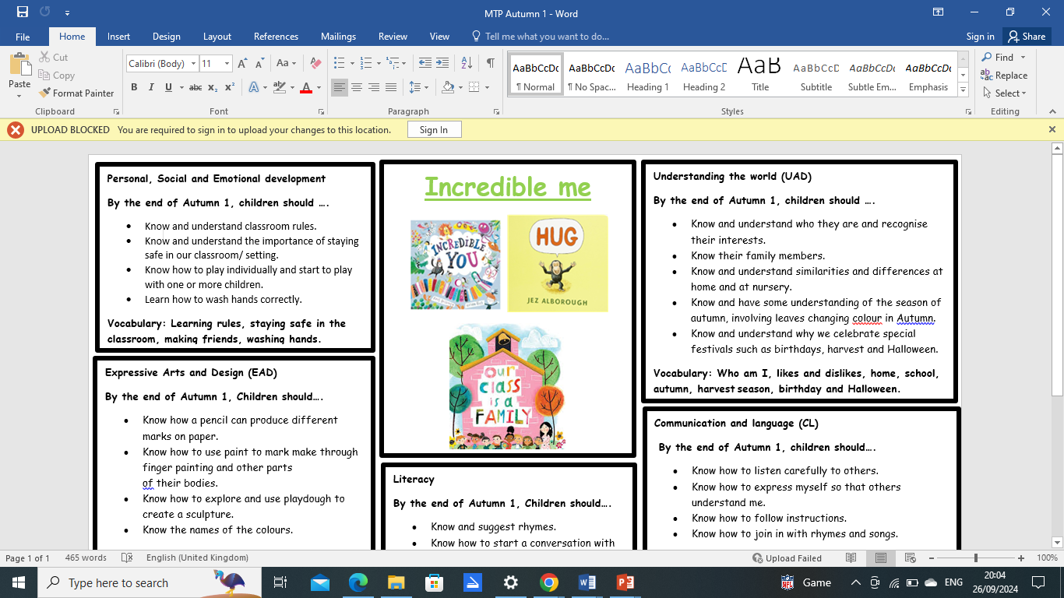**Nursery**

**Welcome to Nursery**

Dear Parents,

I would like to welcome you all to Nursery! I am looking forward to seeing you, having fun and getting busy. I would like to take this opportunity to introduce myself and the teachers in Nursery. I will also outline the routines of Nursery.

My name is Miss Survery and I teach Nursery. Mrs Thompson teaches Monday and Friday afternoons. In addition, Miss Moraru is the teaching assistant.

If you have a query or want to discuss any matters, just let me know and I will answer any questions you may have or arrange a time to discuss this further. A copy of this letter will also be posted on our class page on the school website for you to refer back to if needed.

**Drop-off and Collection**

Morning sessions starts at 8:45 am and finishes at 11.45 am. Afternoon sessions start at 12:15 pm and finish at 3:00 pm. At the end of each session, I will dismiss children individually, when I see their parent. Initially, this may take a little time, however once I learn all of your faces, I will get quicker!

Please let me know if another family member or friend is picking your child up that day. If you have any concerns over how your child is settling, please do not hesitate to contact me.

**Snacks and drinks**

For snack time, we provide fruits and milk / water every day. This normally takes place at 9: 30 am, and this is for our morning children. In the afternoon, snack time takes place at 2: 40pm.

In order to maintain up to date records, please could you let me know of any allergies, medication or dietary requirements your child may have.

**Clothing**

Please could you place a set of spare clothes, shoes and socks in your child’s bag every day, as the children may have accidents. The children will be encouraged to change into their dry clothes with support from the staff. We would ask that all items of clothing, coats and jumpers are labelled clearly with your child’s name.

**Class Topic**

Our topic this half term is “Incredible me”. In this topic, the children will be learning about themselves and their characteristics. There will be many more fun activities for the children to do and we cannot wait to get started!

**PE**

PE will take place every Monday afternoons and Tuesday morning. For the near future, PE will only take place indoors. Please could your child come to school already dressed in joggers/leggings, T-shirt, trainers.

**School Website**

Please visit our class page regularly. I will post regular photos and videos in order to share all the great experiences we are having in Nursery.

I hope that this answers any questions you have. If there are any further queries, please do not hesitate to contact me.