[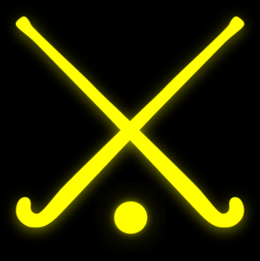](https://www.google.co.uk/url?sa=i&rct=j&q=&esrc=s&source=images&cd=&cad=rja&uact=8&ved=2ahUKEwir9r_q8YnaAhVIsaQKHRefDDIQjRx6BAgAEAU&url=http://www.clker.com/clipart-gold-field-hockey-sticks.html&psig=AOvVaw3yn3__e_DVJFNz5ICF7h3E&ust=1522149538858881)[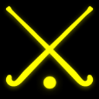](https://www.google.co.uk/url?sa=i&rct=j&q=&esrc=s&source=images&cd=&cad=rja&uact=8&ved=2ahUKEwir9r_q8YnaAhVIsaQKHRefDDIQjRx6BAgAEAU&url=http://www.clker.com/clipart-gold-field-hockey-sticks.html&psig=AOvVaw3yn3__e_DVJFNz5ICF7h3E&ust=1522149538858881)**[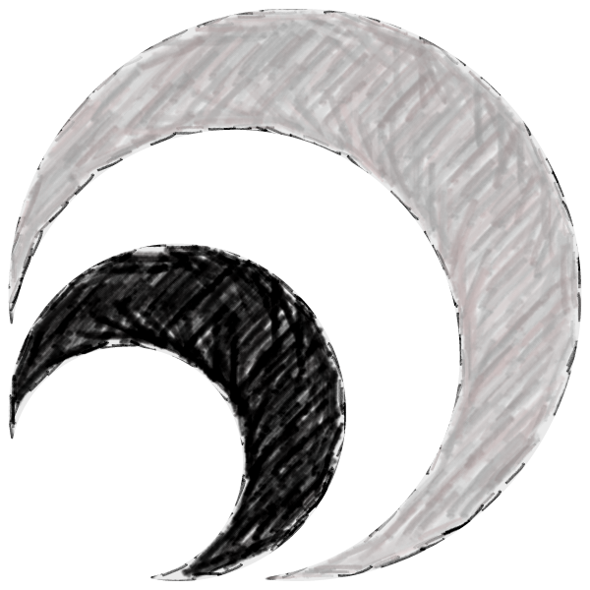](https://www.google.co.uk/url?sa=i&rct=j&q=&esrc=s&source=images&cd=&cad=rja&uact=8&ved=0ahUKEwi8luHji8fSAhWGnBoKHSRnAF0QjRwIBw&url=https://silverfx.co.uk/category/sports-clubs/blackburn-northern-sports-club/&bvm=bv.148747831,bs.1,d.ZGg&psig=AFQjCNErkjhRGWbExT4B30x-7Abr5zfmsw&ust=1489068820335128)Satellite Club**

**When are the sessions?**

**Every Wednesday Evening**

**18:00 – 19:00**

**Where are the sessions?**

**Blackburn Northern Sports Club-Pleckgate High School, BB1 8QA**

**How do I get in contact if I have any questions?**

**Call or Text Hannah**

**07855 337708 or Email** **hockeysection@hotmail.com**

**How much does it cost?**

**Just £2 a session Pay as You Go**

**Can I just turn up?**

**Yes, you can just turn up, no booking required!!**

**bring a family member with you and they can join in too**

**Social Media**

**CLITHEROE & BLACKBURN NORTHERN HOCKEY CLUB**

* Session for both male and female
* Ages 8-13, 14-25 and 25+
* All abilities welcome – no experience necessary
* Sticks provided – just wear general sports clothing and trainers
* Friendly, experienced coaches
* First session FREE
* Sessions start on Wednesday 18th April

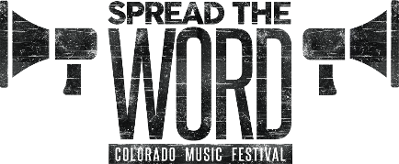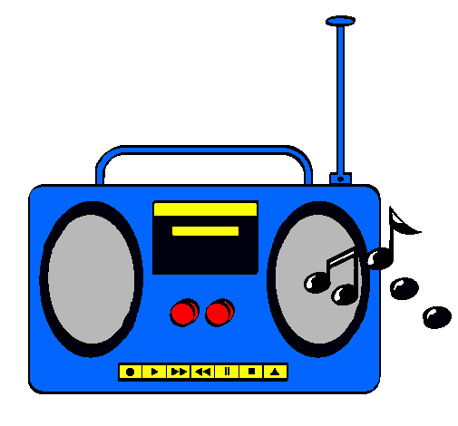**[](https://www.google.co.uk/url?sa=i&rct=j&q=&esrc=s&source=images&cd=&cad=rja&uact=8&ved=0ahUKEwi8luHji8fSAhWGnBoKHSRnAF0QjRwIBw&url=https://silverfx.co.uk/category/sports-clubs/blackburn-northern-sports-club/&bvm=bv.148747831,bs.1,d.ZGg&psig=AFQjCNErkjhRGWbExT4B30x-7Abr5zfmsw&ust=1489068820335128)**

**Facebook – Join us**

**Blackburn & Clitheroe Hockey Section Players Page**

**Twitter - @CBNHOCKEY**