2025- 2026 | Autumn 1  Harvest Festival  Halloween | Autumn 2  Diwali  Bonfire Night  World Nursery Rhyme Week  Remembrance Day  Christmas | Spring 1  New Year  Chinese New Year  Valentine’s Day  Pancake Day | Spring 2  World Book Day  Mother’s Day  Easter Sunday  Eid ul Fitr (Ramadan) | Summer 1  Father’s Day | Summer 2  Sports Day  Nursery Graduation  Eid ul Adha (sacrifice)
Theme | Incredible me | Let’s celebrate | Ticket to Ride | Growing | Amazing Animals | Fun at the sea side
Communication and language  Children engage in stories, songs, rhymes, poems and non-fiction texts. |   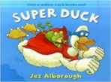  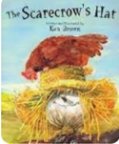  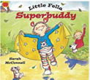  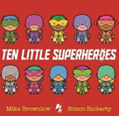  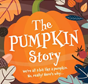 | 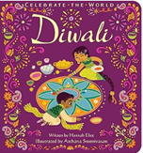  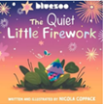  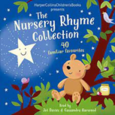  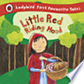  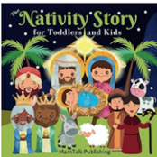  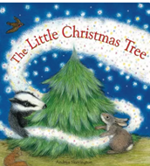 | 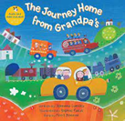  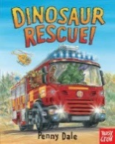  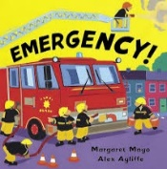  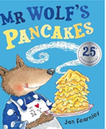 | 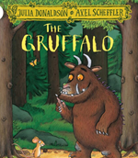  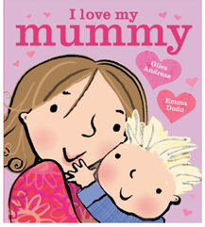  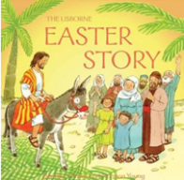  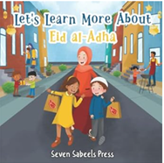    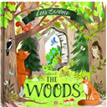 | 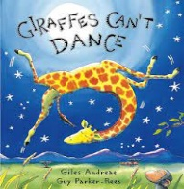  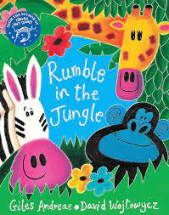  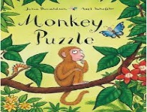  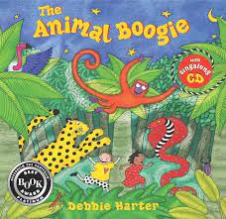 | 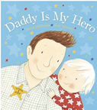    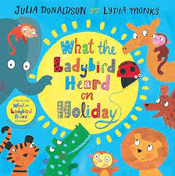
Personal, social and emotional development | Baseline  Learning rules  Staying safe in the classroom  Making friends  My family  Washing hands | Playing and communicating with others  Carrying our tasks  Taking turns  Choosing suitable clothing (weather)  Washing hands | Sharing  Following rules  Feelings  Being independent – pouring a drink, eating  Brushing teeth (Link to UTW)  Washing hands | Taking turns  Following rules  Feelings  Being independent –  Dressing/undressing (ongoing)  Washing hands | Is that what friends do?  Feelings  Being independent –  Toileting/ washing hands  Choosing suitable clothing (weather)  Washing hands | Is that what friends do?  Feelings  Being independent –  Toileting/ washing hands  Washing hands
Physical development | Baseline  Circle games  Using/handling equipment  Dressing up | Large movements  Spatial awareness – Hall  Dressing up  Using/handling equipment  Putting coat on | Moving in different ways  Healthy eating (ongoing)  Using/handling equipment  Putting coat on/taking it off | Balancing  Climbing equipment  Using/handling equipment  Putting coat on/taking it off | Bikes and scooters  Games  Fastening coat | Team games  Sports day  Fastening coat
Literacy | Sound discrimination – environmental | Sound discrimination – instrumental | Sound discrimination – body percussion | Rhythm and rhyme | Voice sounds | Oral segmenting and blending
Mathematics | Number songs/rhymes  Subitise 1- 3  Recite numbers to 5.  Positional language  2D shapes – circle | Recognising numbers  Subitise 1- 3  Matching numerals and objects  Language of size  Shape pictures  Patterns all around us | Representing numbers  Subitise 1- 3  Recite numbers to 5 and above  Language of size  3D – building | Representing numbers  Subitise 1- 5  Recite numbers to 5 and above  Repeating patterns Sequencing language  Language of length | Comparing amounts  Problem solving  Subitise 1- 5  Language of weight  ABAB pattern | Problem solving  Subitise 1- 5  Language of capacity
Understanding the world | Something special to me  Body parts  Autumn (seasons)  Harvest  My school  My birthday | My house  Christmas  Diwali  Bonfire Night  Day and Night  Signs of Autumn/Winter  Sleeping animals | People who help us, our community  Fire brigade, police, doctor, dentist (visits)  Chinese New Year  Seasons Winter | When I was a baby  Chicks  Baby animals  Easter  Seasons Spring | Mini-beasts  Habitats  Life cycle of a butterfly,  Seasons – Summer | Dinosaurs  Animals at the zoo  My favourite pet  Fish
Expressive art and design | Naming colours  Portraits  Singing simple songs | Colour mixing, Pattern making Collage - texture | models Choosing / selecting own resources | Paper mache  Printing | Mask making Den making | Painting and drawing

