

Year 2

Spring Term 2 2026

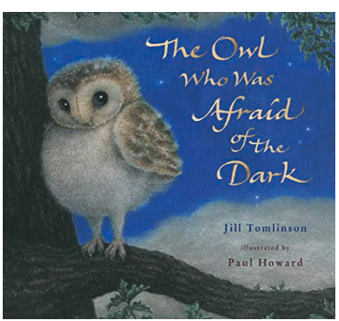

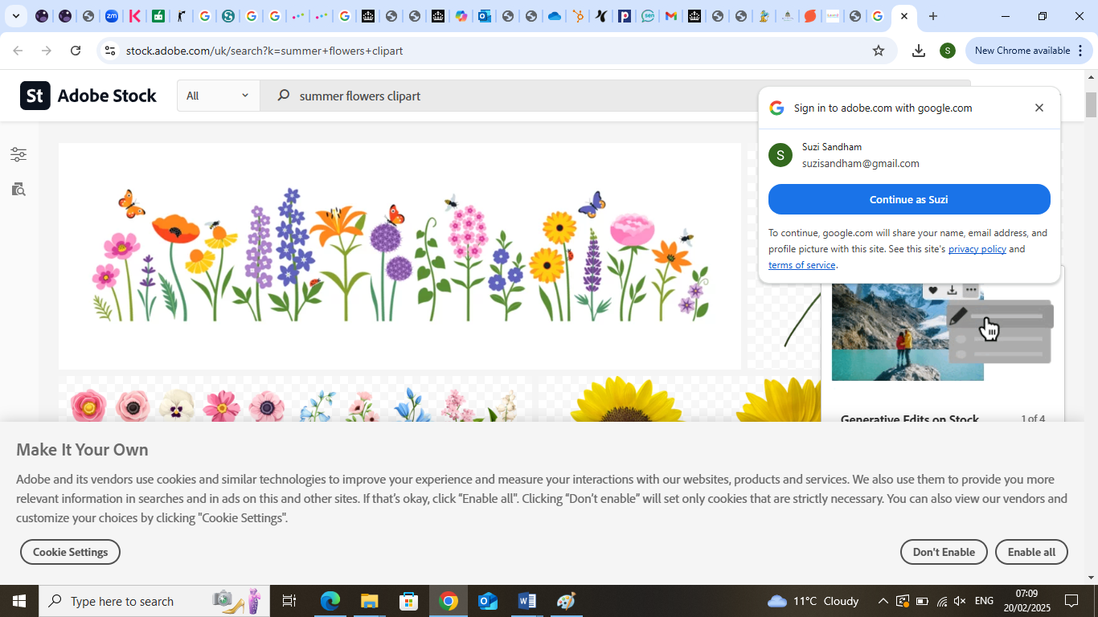

Welcome to year 2
Glossary
Below are the key words your child will be using in class this half term.
Please help your child to complete the glossary and be able to use and spell the words.
Please feel free to add any additional topic related vocabulary that you can think of.

Word | Definition
Root
Bulb
waterfall
River
Creatures
Fraction
Numerator
Denominator

Over the next half term, your child will be
Working on:
Narrative – The Owl Who Was Afraid of the Dark
Multiplication and division, fractions
Learning about the growth of seeds and plants
Learning about the music over the generations
Healthy food DT
Learning about the features of the Northern Territory compared to Blackburn

Your child needs your help and involvement! Please get involved by:
• Discussing the new vocabulary with your child.
• Regularly practising times tables. (Children receive a badge and certificate when they remember a set of times table facts e.g. 2 times table and division facts)
• Regularly practising spellings
• Encouraging your child to do some reading for at least 5 minutes every day, independently or to an adult.
Routines
PE: Indoor PE will take place on a Wednesday and outdoor PE will be on Friday.

Homework
Reading | Try to listen to you child read a little each day. Books will be changed every Monday, Wednesday and Friday. Please remember to sign diaries.
Homework log | Complete homework in green homework log book to earn house points and tickets. These will need to be returned on Thursday, for new homework tasks to be given again on Friday.
Spellings/maths facts | Spellings/maths facts will be sent home on Friday and children will be tested the following Friday. Please remember to return spellings/maths facts book for new ones to be stuck in.
Library | Library books will be changed every Tuesday.

