Autumn 1 | Autumn 2 | Spring 1 | Spring 2 | Summer 1 | Summer 2
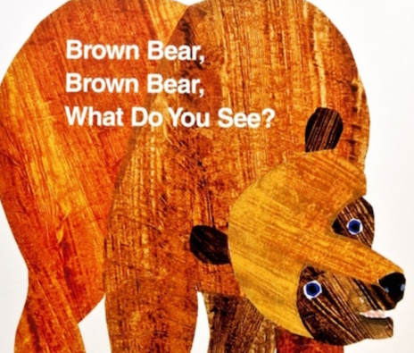  Polar Bear, Polar Bear, what do you hear?  We’re going on a Bear Hunt | 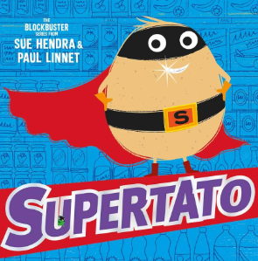  Supertato -Veggies Assemble  Lost and Found | 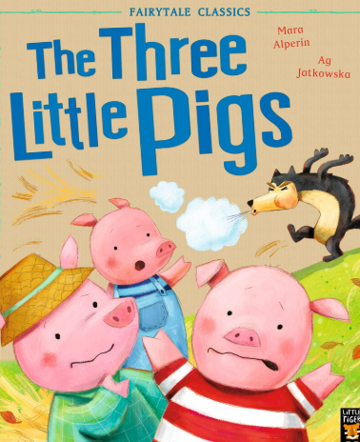  The Three Little Wolves and the Big Bad Pig  Little Red Riding Hood  Jack and the Beanstalk | 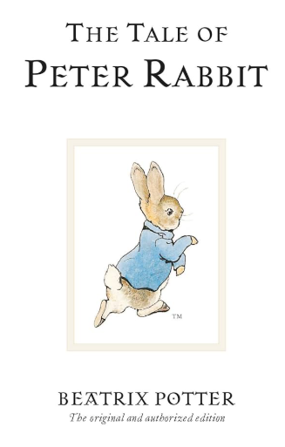  On Safari  The Gingerbread Man | 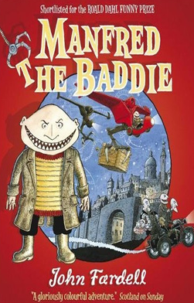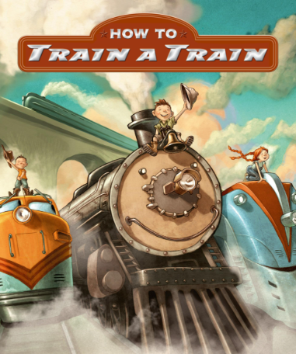 | 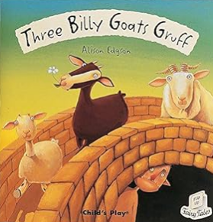  Goldilocks and the Three Bears
Focus writing outcomes  Simple sentences  Repetitive sentences  Labels  Lists | Focus writing outcomes  Simple sentences  Recounts  Descriptions  Sentences with the conjunction-and  Acrostic poems | Focus writing outcomes  Traditional tales  Character descriptions  Setting descriptions  Repetitive stories | Focus writing outcomes  Shape poems- calligrams  Fact files  Information texts  Instructions (recipes) | Focus writing outcomes  Instructions  Character interviews  Character descriptions  Setting descriptions  Riddles | Focus writing outcomes  Different traditional tales  Innovate their own repetitive stories  Recounts-trips/events
Grammar  Proper nouns-capitals including pronoun I  Capital and lower case  Full stops  Finger spaces | Grammar  Singular and plural words-adding s/es  Nouns  Verbs  Adjectives  Sentence order/sense introduce the conjunction-and | Grammar  Suffixes-ing/ed/er  Prefixes-un  Adjectives-adding er/est suffixes  Conjunctions-and/because | Grammar  Question marks  Exclamation marks  Adjectives  Verbs  Conjunctions  Plurals-adding s/es | Grammar  Compound words  Days of the week  Alphabet-order  Verbs  Proper nouns-places, days of the week, people and pronoun-I | Grammar  Question marks  Exclamation marks  Adverbs  Adjectives  Conjunctions  Prefix-un, revision
Spelling/Phonics  Reception CEW  Phase 3 phoneme revision from Reception ai, ee, igh, oa etc  Introduce Phase 5 ay, ou, oy and ea (Little Wandle) | Spelling/Phonics  Reception CEW  Phase 5 continued ir, ie, ue, u etc (Little Wandle) | Spelling/Phonics  Year 1 CEW  Phase 5 alternative sounds-y, ea, wh, oe etc (Little Wandle) | Spelling/Phonics  Year 1 CEW  Phase 5 alternative sounds-or, oul, are, au etc (Little Wandle) | Spelling/Phonics  Year 1 CEW  Phase 5 revision starting with ay, ea etc etc (Little Wandle) | Spelling/Phonics  Year 1 CEW  Phase 5 alternative sounds- ey, aigh, eigh etc including silent letters too eg, mb, kn, gn etc
Comprehension  Collins Big Cat  Little Wandle Guided Reading Books  Phases 2/3/4/5 | Comprehension  Little Wandle Guided Reading Books  Phases 2/3/4/5 | Comprehension  Little Wandle Guided Reading Books  Phases 2/3/4/5 | Comprehension  Little Wandle Guided Reading Books  Phases 2/3/4/5 | Comprehension  Little Wandle Guided Reading Books  Phases 2/3/4/5 | Comprehension  Little Wandle Guided Reading Books  Phases 2/3/4/5

