Autumn 1 | Autumn 2 | Spring 1 | Spring 2 | Summer 1 | Summer 2
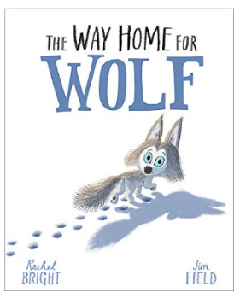  Narrative: Corin’s First Day  Bridging Unit: The Way Home For Wolf | 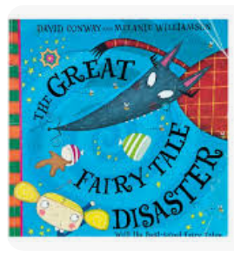  Talk Unit: Traditional Tales: The Great Fairy Tale Disaster  Poetry: four seasons  Instructions: How to make a hand puppet. | 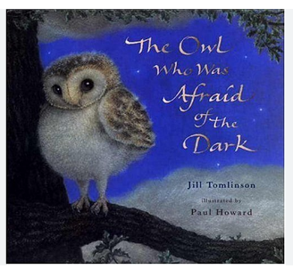  Talk Unit; Amazing birds  Narrative: The Owl who was Afraid of the Dark  Poetry – Riddles | 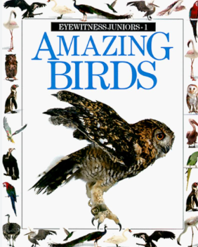  Talk Unit; Amazing birds  Non-Chronological report 2-3 wks.  Persuasion poster | 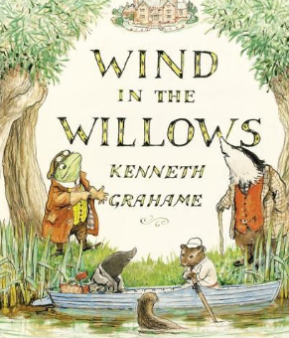  Talk Unit – Narrative Classic Story : The Wind in the Willows  Recount  Diary: The Great Fire Of London | 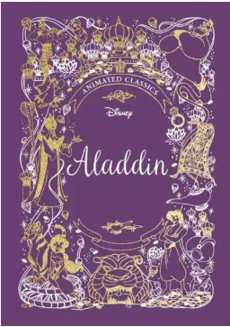  Talk Unit –  Narrative : Aladdin  Explanation: If you want to be healthy
Focus writing outcomes  Character description  Setting description  Recount  Story structure  beginning, middle, end | Focus writing outcomes  Sequence events  Traditional tale with a twist  Instructions  Describing weather  Poem – seasons | Focus writing outcomes  Persuasive letter  Address  Email  Character hot seat  Adventure story  Describing feelings  Scientific Report (science) | Focus writing outcomes  Story starters  Research  Poem – life cycle of a bean  Labelled diagram  Blurb  Fact file (History | Focus writing outcomes  Description of Events  Timeline of events  Research –non-fiction texts  Diary Extract  Handwritten notes  Recount | Focus writing outcomes  Research  Story structure  Persuasive poster  Explanation  List  Recipe (DT)
Grammar  Revision of capital letters and full-stops.  Noun  Adjectives  Verbs  Sentence types  Plural s es  Conjunctions co-ordinating  Past tense | Grammar  Adjectives  Noun phrases  Subordination using when, before and after.  Homophones  Contractions/possession  Sentence types  Commas in a list  Present tense | Grammar  Revision  Apostrophes for Contractions/possession  Expanded noun phrases  Conjunctions  Homophones  Adverbs | Grammar  Revision  Homophones  Conjunctions  Commas in a list  Sentence types  Tenses | Grammar  Expanded noun phrase  Past tense  Commas in a list  Sentence types - Exclamations  Apostrophes Contractions/possession  Adverbs | Grammar  Subordination  Past /present tense  Consolidation of learning  Homophones  All sentence types  Conjunctions  Commas in a list
Spelling/phonics  Phase 5 consolidation  Revision of Year 1 CEW  ‘d’ spelled as ‘ge’ and ‘dge’ at the end of words  ‘s’ spelled ‘c’ before ‘e’, ‘I’ and ‘y’  ‘n’ spelled kn- and gn | Spelling/phonics  Phase 5 consolidation  Homophones  sound spelled ‘o’, as in other, mother, brother  contractions  words ending -il, as in p  Days of the week | Spelling/phonics  Phase 5 consolidation  Revision  Yr 2 CEW  the /l/ or /əl/ sound,  le at the end of words  the /l/ or /əl/ sound spelled -el at the end of words  the /l/ or /əl/ sound spelled -al at the end of words | Spelling  Homophones  the /aɪ/ sound spelled -y at the end of words  -es to nouns and verbs ending in -y  suffixes -ed, -ing, -er and -est | Spelling  Revision  CEW  ‘a’ before ‘l’ and ‘ll’  -ey, as in key, donkey, valley  a’ after ‘w’ and ‘qu’ | Spelling  ‘or’ after ‘w’  ‘ar’ after ‘w  ‘s’, as in television  suffixes -ment, -ness, -ful, -less and –ly, tion  possessive apostrophe
Comprehension  Cracking comprehension units 1 - 3  Letts guided read 2:1  Little Wandle | Comprehension  Cracking comprehension units 4 -6  Letts guided read 2:1  Little Wandle | Comprehension  Cracking comprehension units 7-9  Letts guided read 2:2  Little Wandle | Comprehension  Cracking comprehension units 10-12  Letts guided read 2:2  Little Wandle | Comprehension  Cracking comprehension  units 13-15  Letts guided read 2:3  Little Wandle | Comprehension  Cracking comprehension  units 16-18  Letts guided read 2:3  Little Wandle
Handwriting  Letter families  CVC dictation  High frequency words | Handwriting  Diagonal joins  Dictation  High frequency words | Handwriting  Horizontal joins  Letter ‘f’ ‘k’ d, b,  Dictation  High frequency words | Handwriting  Horizontal joins  Letter w, ‘s, z,  Dictation  High frequency words | Handwriting  Grammar and spelling  Dictation  High frequency words | Handwriting  Grammar and spelling  Dictation  High frequency words

