Autumn 1 | Autumn 2 | Spring 1 | Spring 2 | Summer 1 | Summer 2
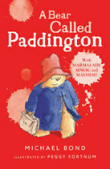  A Bear Called Paddington | 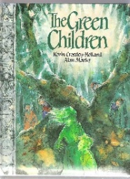  The Green Children | 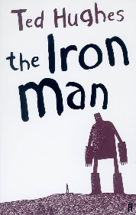  The Iron Man | 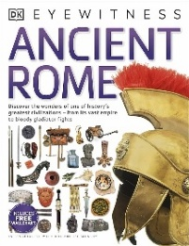  The Romans | 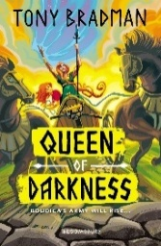  The Romans: Boudicca | 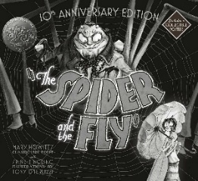  The Spider and the Fly
Text type  Classic Stories  Information Guides | Text type  Folk Tales  Instructions  Recount: Letters | Text type  Novel as a Theme  Classic Poetry  Recount: Diaries | Text type  Information Text: Leaflets | Text type  Historical Narrative | Text type  Recount: Crime Report  Persuasion: Menu  Persuasion: Letters
Focus writing outcomes  Narrative based on a model  Information leaflet | Focus writing outcomes  Folk tale based on a model  Recount: letter in role  Instructions | Focus writing outcomes  Narrative based on a model  Instructions | Focus writing outcomes  Tri-fold information leaflet | Focus writing outcomes  Narrative historical stories | Focus writing outcomes  Narrative stories inspired by poetry  Persuasive letters
Grammar  Commas  Noun phrases  Statements, questions, exclamations  Compound words | Grammar  Conjunctions  Inverted commas  Determiners | Grammar  Conjunctions  Main / subordinate clauses  Commas | Grammar  Conjunctions  Main / subordinate clauses  Commas | Grammar  Adverbs for how / when  Fronted adverbials for when / where  Prepositions for where | Grammar  Conjunctions  Inverted commas  Noun phrases / expanded noun phrases  Adverbs for how / time
Spelling  Y2 suffixes -ed, -ing, -er, -est  Y2 suffixes -ness, -ment, -ful, -less  Y3/4 word list spellings  ‘i’ sound spelt with a ‘y’  ‘u’ sound spelt ‘ou’  Own spelling errors | Spelling  ‘ai’ sound spelt ‘ei’, ‘eigh’, ‘ey’  Prefixes un-, dis-, mis-  Adding suffixes  Split digraphs  Y3/4 word list spellings  Own spelling errors | Spelling  Autumn term review 1  Autumn term review 2  Y3/4 word list spellings  Prefix re-  Prefix super-  Own spelling errors | Spelling  Prefixes anti- and sub-  Prefix auto-  Prefix inter-  Homophones and near homophones  Y3/4 word list spellings  Own spelling errors | Spelling  Spring term review 1  Spring term review 2  Y3/4 word list spellings  Suffix -ly  Suffix -ly  Own spelling errors | Spelling  Suffixes -ally, -ation  Suffixes vowel letters  Endings -sion and -tion  Prefixes in- and il-  Prefixes im- and ir-  Y3 words review from Y3/4 word list

