Autumn 1 | Autumn 2 | Spring 1 | Spring 2 | Summer 1 | Summer 2
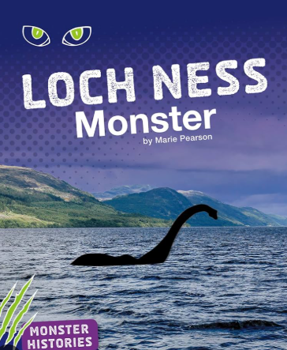  The Loch Ness Monster | 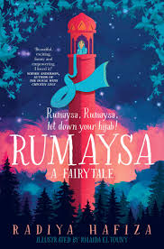  Rumaysa | 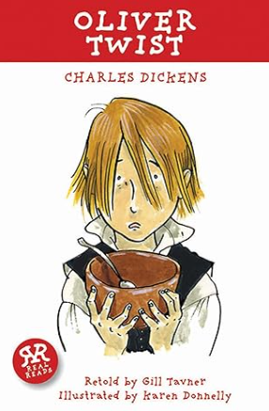  Oliver! | 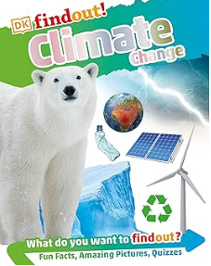  Climate Change | 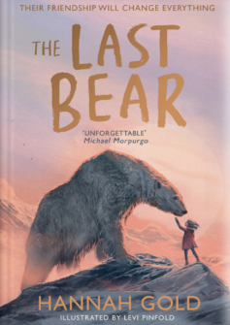  The Last Bear | 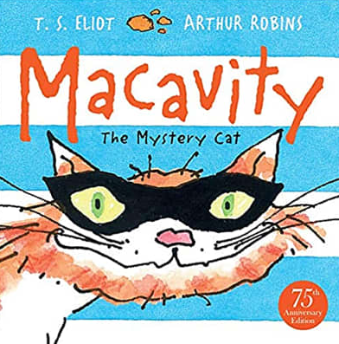  Macavity
Focus writing outcomes  Information Texts: Magazine Article  Information Text: Infographic  Story as a Theme  Poetry Performance  Film Narrative | Focus writing outcomes  Fairy Tales  Song Lyrics | Focus writing outcomes  Balanced Arguments  Newspaper articles  Character Profiles | Focus writing outcomes  Explanation Text: Documentary | Focus writing outcomes  Persuasive Poetry  Narrative Story Openings | Focus writing outcomes  Classic Poetry  Poetry Performance  Recounts: News Broadcasts  Recounts: Newspaper Articles
Grammar  Complex sentences using a range of conjunctions  Comma to separate clauses in complex sentences where the subordinate clause appears first  Commas to mark clauses in complex sentences  Explore, identify and use Standard English verb inflections for writing | Grammar  Use inverted commas to punctuate direct speech (speech marks)  Use inverted commas and other punctuation to indicate direct speech  Improvise and compose dialogue, demonstrating their understanding of Standard and non-Standard English  Use nouns for precision  Fronted adverbials for when | Grammar  Fronted Adverbials for how and when  Prepositions  Expanded noun phrases  Commas after a fronted adverbial  Inverted commas | Grammar  Identify, select and use determiners  Fronted adverbials for where | Grammar  Identify, select and effectively use pronouns  Complex sentences with adverb starters | Grammar  Apostrophes for singular and plural possession  Apostrophes for contractions  Commas to mark clauses  Commas in a list  Noun phrases and expanded noun phrases
Writing Outcomes  Letter to a family member  Infographic of key facts.  Practice Write of an introduction.  Class debate/talk show.  Character profile/s  Description/sighting of Nessie  Creature description.  Interchanges of dialogue. | Writing Outcomes  Response to Elements of Fiction prompts  Character Description (opinions and summary)  Reading Domain – Appeal to Reader response  Letter in role.  Noun Phrase poem  Poem to Paragraph  Short Burst Practice Write of dialogue following drama | Writing Outcomes  Setting description  Character description  Response to reading domain prompt – character inference  Use of inverted commas for speech.  Character comparisons | Writing Outcomes  Explanation paragraph on climate change.  Independent explanation paragraph of the effect of climate change on polar bears. | Writing Outcomes  Response to reading domain prompt – character inference  Modelled and independent short burst practice write using the toolkit to blend character and setting in an opening.  Modelled persuasive poem.  Independent persuasive poem. | Writing Outcomes  Detective Notepad  Summarising  Dictated sentences  Text messages  Victim report  Modelled and independent imitation write
Linked texts:  History's Mysteries: Freaky Phenomena: Curious Clues, Cold Cases, and Puzzles From the Past National Geographic Kids by Kitson Jazynka  Nessie – The Most Famous Tale of Monster Mayhem Ever by Richard Brassey  Legend of Loch Ness Monster for Kids by Amber Richards | Linked texts:  The Three Impossibles by Susie Bower  Rumaysa Ever After by Radiya Hafiza | Linked texts:  Harry Potter and the Philopsopher’s Stone  Another Twist in the Tale by Catherine Bruton | Linked texts:  Hunter's Icy Adventure by Ellie Jackson  The Ultimate Polar Bear Book for Kids by Jenny Kellett  A Climate in Chaos by Neal Layton  DK Find Out! Climate Change  What is Climate Change by Gail Herman  Stuff by Maddie Moat  Climate Emergency Atlas by DK | Linked texts:  The Lost Whale by Hannah Gold  Finding Bear by Hannah Gold | Linked texts: Old Possum's Book of Practical Cats by T.S. Eliot  Max The Detective Cat series by Sarah Todd Taylor  Attiucus Claw series by Jennifer Gray  Varjak Paw series by SF Said  The Mousehole Cat by Antonia Barber  Six Dinner Sid by Inga Moore  The Evil Society of Cats by Pandania  Toto the Ninja Cat by Dermot O'Leary
Spelling rules:  Suffixes  Prefixes  ¾ word list  Missing letters  Suffixes (vowel letters) | Spelling rules:  -sion and –tion  -ssion  -ation  -cian  ¾ word list | Spelling rules:  Recap Autumn  Review  ¾ spelling list  -ous  Individual spellings | Spelling rules:  /k/ spelled ‘ch’  Review  ¾ word list  /sh/ spelled ‘ch’  Unstressed vowels | Spelling rules:  Review  ¾ word list  /sh/ spelled ‘ch’  -gue endings | Spelling rules:  -que endings  /s/ spelled ‘sc’  Homophones  Near homophones  Un-, dis-, mis- and re

