Autumn 1 | Autumn 2 | Spring 1 | Spring 2 | Summer 1 | Summer 2
The Lion, the Witch and the Wardrobe  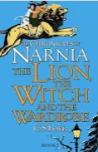 | Legends  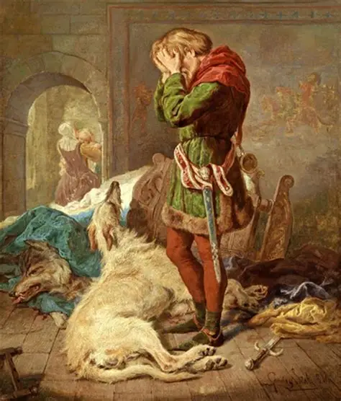 | Earthlings  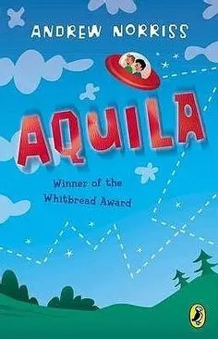 | Inventors and Inventions  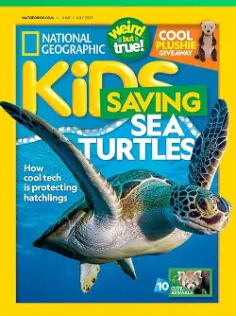 | Faster Higher Stronger  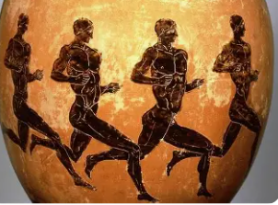 | Jabberwocky  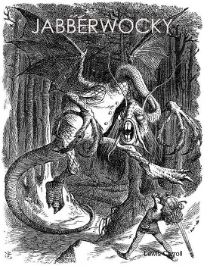
Text type:  Integrated Unit  Classic Narrative  Non-Chronological Report | Text type:  Classic Narrative  Character description  Setting description | Text type:  Classic narrative  Persuasive letter  Setting description  Science Fiction story  Poems with a structure | Text type:  Integrated unit  Non-fiction  Magazines: information text hybrid  Novel as a theme | Text type:  Integrated unit  Myths  Non-fiction  A non-chronological report about an aspect of the Olympics  Poems with figurative language | Text type:  Integrated Unit  Classic Narrative Poetry  Informal Letters  Narrative: Action Scenes  Narrative: Retelling with Language from the Text
Skill focus:  - Fronted adverbials for when  - Fronted adverbials for where  - -ing opening clauses  - Brackets to indicate parenthesis  - Commas to indicate parenthesis  - Expanded noun phrases | Skill focus:  - Expanded noun phrases  - Commas to clarify meaning and avoid ambiguity  - Use adverbials to link paragraphs  - Simile starters  - To use adverbs and modal verbs to indicate degrees of possibility  - Use dialogue to convey a character | Skill focus:  - Short sentences for action  - Commas to indicate parenthesis  - Simile starters  - Expanded noun phrases  - Metaphors  - Personification | Skill focus:  - Create complex sentences by using relative clauses  - Identify and use commas, brackets and dashes for parenthesis  - Use organisational and presentational devices  - Note and develop ideas  - Select the appropriate language and structures e.g. headings, bullet points, subheadings | Skill focus:  - Create and punctuate complex sentences using simile starters  - Blend action, dialogue and description across paragraphs  - Link ideas across paragraphs using adverbials for time, place and numbers  - Use devices to build cohesion within a paragraph e.g. firstly, then, presently, this, subsequently | Skill focus:  - Relative clauses with relative pronouns and commas.  - Cohesive devices.  Blend action dialogue and description
Writing Outcomes:  Modelled and independent non-chronological report based upon mythical creatures in literature.  Modelled and independent narrative based on a model text with an innovated plot structure. | Writing Outcomes:  Character description  Modelled and independent narrative based on a legend  Setting descriptions | Writing Outcomes:  Short poems  Persuasive letter  Creating atmosphere  Character description  Modelled and independent fictional narrative based upon an alien landing on Earth | Writing Outcomes:  Modelled and independent non-fiction article for a magazine based around the invention of Lego  Fact files  Multiple choice quizzes  Lego review | Writing Outcomes:  Modelled and Independent short story based on a Greek Myth.  Character description | Writing Outcomes:  Poetry response  For/against discussion text  Letter in role  his intention to slay the Jabberwock  Poetry  Non-chronological report  Action scene narrative
Linked texts:  Evacuees of the Second World War by Chris McNab  Prince Caspian by C. S. Lewis  The Voyage of the Dawn Treader by C. S. Lewis | Linked texts:  The Legend of Gelert  The Legend of King Arthur  Finn MacCool and the Giant’s Causeway | Linked texts:  Aquila by Andrew Norris  George’s secret key to the universe by Lucy Hawking  Alien schoolboy’s Z to A guide to Earthlings by Ros Asquith  The Kid who came from Space by Ross Welford | Linked texts:  Eco Kids Planet Magazine  National Geographic KiDS Magazine  First New  The Week Junior | Linked texts:  The Orchard book of Greek Myths by Geraldine Mccaughrean  Greek Myths by Marcia Williams  The Fire Thief by Terry Deary  Zues on the Loose! By John Dougherty  Who Let the God’s Out? By Maz Evans | Linked texts: Jabberwocky – Lewis Carroll  The Return of the Jabberwock - Oakley Graham  Jabberwocky by Lewis Carroll  Illustrated by Paul Elwin Rodgers (2013)  Other poems by Lewis Carroll:  The Lobster Quadrille  Twinkle, Twinkle, Little Bat How doth the little crocodile Tis the voice of the Lobster Turtle Soup  The Mouse’s tale
Spelling rules:  Prefixes  Suffixes  Year 3-4 CEW  -ough words  Yrs 5 CEW  Homophones | Spelling rules:  Individual spellings’-cious/-tious words  -cial/-tial words  Focus words  Focus words  Individual spellings | Spelling rules:  Recap Autumn  -able/-ible words  -ably/-ibly words  Homophones  Yr5 CEW  Individual spellings | Spelling rules:  Silent letters  -ant/-ent  -ancy/-ency  Homophones  Yr5 VEW  Individual spellings | Spelling rules:  Recap Spring  Prefixes  Suffixes  Homophones  Yr5 CEW  Individual spellings | Spelling rules:  Homophones  Apostrophe  Adjectives/adverbs  Yr5 CEW  Technical language  Recap Yr5 CEW

