Autumn 1 | Autumn 2 | Spring 1 | Spring 2 | Summer 1 & 2
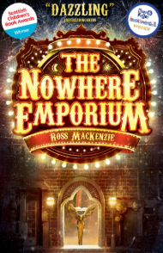  The Nowhere Emporium | 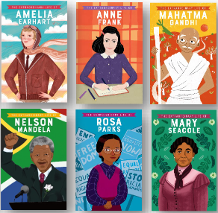  Biography | 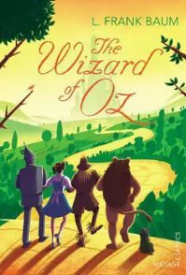  The Wizard of Oz by L Frank Baum | 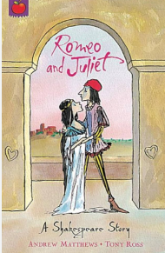  Romeo and Juliet | 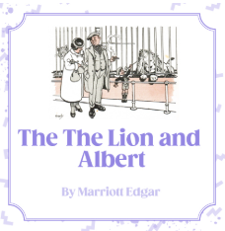  The Lion and Albert
Text type:  Story as a Theme  Information Hybrid (magazine page) | Text type:  Biography  Song/poetry | Text type:  Classic fiction | Text type:  Older Literature – Play as a Theme | Text type:  Novel as a Theme
Skill focus:  ing opening clauses,  Simile starters, manipulate sentences for effect.  Blending action, dialogue and description,  Relative clauses,  Commas to clarify meaning | Skill focus:  Manipulate sentences to Create particular effects  Relative clauses  Use devices to build cohesion between paragraphs.  Use a range of organisation and presentational devices to structure text | Skill focus:  Formal and informal language,  Blending action, dialogue and description  Synonyms and antonyms | Skill focus:  A range of skills depending on the needs of the class | Skill focus:  A range of skills depending on the needs of the class
Writing Outcomes:  Narrative based on a model text with an innovated plot structure  A magazine page based on magic or the circus | Writing Outcomes:  Biography based on a key person,  Oral presentation of a poem/song, Reading journal entries detailing personal reflections and responses to songs and poems  Song lyrics / poem | Writing Outcomes:  Story based on a text read following a suggested plot pattern.  Change of viewpoint – story written in first person based on scaffolded sequence of events | Writing Outcomes:  Narrative retell – various scenes across the play  Acrostic poem  Recount – diary  Recount – letter,  Persuasive advert script.  Poetry from different perspectives.  Cartoon scene summary.  Song lyrics.  Interviews.  Witness statement.  Newspaper report.  Discussion text.  Retell of play. | Writing Outcomes:  narrative: 1st person perspectives (diary entries)  Short flashback story, emails, letters, adverts and reviews.
Linked texts:  Leon and the Place Between by Grahame Baker-Smith  Harry Potter and the Philosopher’s Stone by JK Rowling  Madame Pamplemousse and Her Incredible Edibles by Rupert Kingfisher  The Elsewhere Emporium by Ross MacKenzie  The Invention of Hugo Cabret by Brian Selznick  The Mystery of the Clockwork Sparrow by Katherine Woodfine  The Otherwhere Emporium by Ross MacKenzie  The Wonder by Faye Hanson | Linked texts:  Goodnight Stories for Rebel Girls series by Elena Favilli and Francesca Cavallo  The Extraordinary  Lives (various authors)  Stories for Boys who Dare to be Different series by Ben Brooks  The Story Of: A Biography  Series for New Readers series (various authors)  It’s Her Story series (various authors)  Just Like Me by Louise Gooding  Perfectly Imperfect stories by Leo Potion and Ana Strumpf  Who Was Walt Disney? by Whitney Stewart  The Story of Walt Disney by Susan B Katz  Who Was William Shakespeare? by Celeste Mannis  Shakespeare for Everyone Emma Roberts  Ducksters.com biography website  A range of relevant biographies on Mini Bios (available on YouTube) | Linked texts:  A Little Princess by Frances Hodgson Burnett  Anne of Green Gables by L. M. Montgomery  Black Beauty by Anna Sewell  The Railway Children by Edith Nesbit  Alice’s Adventures in Wonderland by Lewis Carroll  The Fantastic Flying Books of Morris Lessmore by William Joyce | Linked texts:  William Shakespeare’s Romeo and Juliet: A new adaptation for KS2 and KS3 by Gareth Jones  Mr William Shakespeare’s Plays by Marcia Williams  Shakespeare's First Folio: All the Plays: a Children's Edition, illustrated by Emily Sutton  Romeo and Juliet (A Shakespeare Story) by Andrew Matthews  Films/ extracts from films referenced:  - West Side Story (1961, PG)  - Romeo and Juliet (1968, PG)  William Shakespeare’s Romeo and Juliet (1996, 12) | Linked texts:  The Lion and Albert
Spelling rules:  Silent letters  -ous  Soft C Rule  -ure –gue  -g as j  (near) homophones | Spelling rules:  Year 5/6 words  Suffix -fer  words ending in -gue and -que  ‘ch’ makes ‘k’ sound; ‘ch’ makes ‘sh’ sound  words from the Year 5/6 word list  words from children’s own writing: technical vocabulary  Review of words taught this term | Spelling rules:  words with silent letters  Words ending in –ous  y as I & ch as k/sh  ure & gue  Individual spellings | Spelling rules:  words from children’s own writing and Year 3/4 word list  able/-ably and -ible/-ibly endings  suffixes | Spelling rules:  ough letter string  Homophones  Apostrophes  Year 5/6 word list  strategies for spelling in test conditions  Etymology

