
Griffin Park Primary School
Weekly Newsletter
Date: 8th May 2026
Newsletter Number: 28

HEADTEACHER MESSAGE
It has been a strange week in school this week with the Bank Holiday on Monday and closed for polling yesterday. We have had to cram lots into the three school days we have had.

Today, Year 4 are out at Martin Mere as part of their history topic. They are visiting an ancient village – Mere Tun - and will be learning lots of exciting things about life in the past. I am sure we will have lots more to share with you next week when they return.

Mrs Cameron-Clarke has asked me to mention about behaviour and safety outside of school. We have had reports of children throwing sticks and stones at cars driving past in the area. This is dangerous for both the child, the people in the car and others who may be passing by. Please remind your children about how to stay safe and behave respectfully in the local area.

On Wednesday we had a follow up visit from Jo Bleasdale who is the local authority school effectiveness officer for safeguarding. She was in to see what actions we had taken following a full safeguarding audit in the autumn term. I am pleased to report that she was very impressed with what she saw and how Griffin Park takes safeguarding very seriously. She is also going to help us campaign to make the site more secure for everyone.

One recommendation she gave us was for a website that tests internet safety filters. You can use this to see if your home internet is secure against potential risks and as safe as possible for you and your children. Please go to www.testfiltering.com and give it a go.

On Wednesday, I sent out a survey via ParentMail to see if it would be viable for School’s Out Holiday Squad to help with after school provision for pupils. Please take a minute and complete the survey via this link - https://www.surveymonkey.com/r/RT7MLVP You can check out more about the after school club at www.schoolsoutholidaysquad.co.uk

Earlier this week, Mrs Aspinall received Griffin Park’s first ever attendance award from the Fischer Family Trust. We are incredibly proud to receive this award as the result of lots of hard work from pupils, staff and families of Griffin Park. There is a copy on display in the foyer and one below on this newsletter.

Lastly – please see below for a good luck message to Year 6 for their SATs next week.

Mr Chapman
SUNCREAM, SUNHATS AND WATER BOTTLES
As we are now experiencing warmer weather, we ask that children come into school prepared for being outdoors in the sunshine. They should have a water bottle in school with them every day (only water in these bottles please – no juice!). Clear, plastic, reusable water bottles are best for this. We encourage them to bring in a sunhat to help keep the sun off their faces and necks. If you think they will need suncream, please put it on in the morning before school. Due to potential allergic reactions, we do not allow suncream, lip balm or other creams to be brought into school without prior consent.
KEY DATES

8/05/26 – Y4 Trip to Martin Mere
11/05/25 – SATS Week – Y6 Good Luck
15/05/26 – Y2 Trip to Martin Mere
20/05/26 – Sponsored Welly Walk
21/05/26 – Y4 Class Assembly 9am
22/05/26 – Eid Party. School closes at 3:15/3:20pm for half-term
01/06/26 – School Closed – INSET Day
02/06/26 – School Reopens
01/01/26 – Y4 Multiplication checks this week


STARS OF THE WEEK
Well done to the following children who will receive their certificates on Friday 15/05/26
(* To be awarded in assembly on 22nd May)
YR: Inaya
Y1: Ayyan

Y2: Rabiyah*
Y3: Ernie
Y4: Muhammad Hashim
Y5: Ayesha
Y6: Aliyah

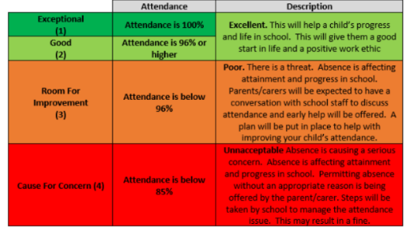
Rec.
96.2
Y1
98.1
Y3
97.6
Y2
99
Y4
93.7
Y6
99
Y5
99
Weekly Attendance Results (%) – Target 96%

YEAR SIX SATS
Dear Year 6,

As you prepare to sit your SATs next week, I wanted to take a moment to say how incredibly proud we all are of each and every one of you. You have shown such hard work, determination and commitment this year, and it has been a joy to see how much you have grown—both in your learning and as young people.

You’ve faced challenges with resilience, supported one another, and kept going even when things felt tricky, and that is something to be really proud of.

The tests ahead are simply an opportunity to show some of what you already know, and we have every confidence that you are ready. Trust yourselves, take your time, and remember all the strategies you have practised. What matters most is that you try your best—that is all anyone can ever ask.

It’s also so important to remember that you are all talented in many different ways that these tests can’t measure. Your creativity, your kindness, your sense of humour, your teamwork, and the way you look after one another are all just as important as anything in a test paper. SATs are important, but they do not define who you are. You are so much more than a set of results, and we value you for the wonderful individuals you are.

Please remember that we are all behind you. Every member of staff is rooting for you and believes in you wholeheartedly. Stay calm, get a good night’s sleep, and come in each day ready to give it your best shot—we’ll be here to support you every step of the way.
Good luck, Year 6—you’ve absolutely got this.

With very best wishes,

Mr Chapman
(On behalf of all the staff and pupils at Griffin Park Primary School)

With the SATs tests next week, Year Six children are invited to come into school from 8:00am to have breakfast with their classmates. We ask that they come to the back door where they will be let into school along with breakfast club. This is a great opportunity for them to socialise and blow away a few cobwebs before each morning’s test – there is no charge for this for year 6 pupils.

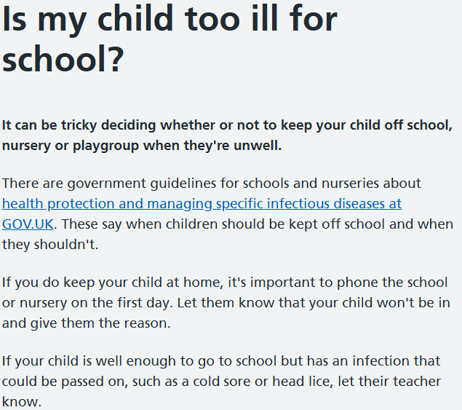



CAR PARKING
Please note that both car-parks, front and rear, are for staff vehicles and deliveries only. Please do not come onto the car parks when dropping children off or collecting them. This includes when dropping off for breakfast club. Please could we also ask that drivers are considerate of road marking when driving around school. Lots of cars are stopping on the yellow zig-zag lines at the front and side of school. these are there to ensure that all our children are kept safe and they should not be used to stop on – even for a few moments.
CUTTING UP FOOD IN PACKED LUNCHES
Please could we ask that any fruits, vegetables and other foods that may present a choking hazard are cut up appropriately if being sent in a lunchbox. For example, grapes, cherries, berries, and tomatoes should be cut into quarters lengthways to minimise the risk of choking. This applies to all children bringing food into school, whatever their age/year group. Please click on the link below for more information on food preparation for children.
https://www.foundationyears.org.uk/files/2021/09/Early-Years-Choking-Hazards-Table_FINAL_21-Sept-2021.pdf

COOL MILK
Dear Parent/Guardian,

As you may be aware Griffin Park Primary School has a milk scheme, now being administered by Cool Milk. Midmorning milk provides a much-needed nutritional boost and keeps children hydrated between breakfast and lunch. Children receive free milk until the age of 5. After that, they Can continue to reap the benefits of fresh mid-morning milk at a subsidised* cost.

If you’d like to opt in and have not already done so, simply register your child at www.coolmilk.com/parents . Your child(ren) will continue to receive free milk whilst under the age of 5 and Cool Milk will get in touch with further information by email shortly before their 5th birthday.

For children who are already over 5, it’s not too late – our scheme is flexible! As well as being able to register and make payment straight away, you can join and cancel the scheme at any time. We offer yearly, termly and half termly payment periods and a recurring payment option to give you one less thing to remember.

If you already have an online Cool Milk account for a sibling, you can manage your account, make payment and add extra children by logging in at www.coolmilk.com/parents

Should you have any questions or need any help, send us a message at www.coolmilk.com/contract or give us a call on the number listed below – we’re here to help!

Kind regards

Griffin Park Primary School, on behalf of Cool Milk

0800 321 3248

Please do not make any further milk payments via ParentPay as the arrangement is now directly between parents and Cool Milk – via their website.
SCHOOL FUND APPEAL
We kindly invite families to support our school fund if they are able. Donations, no matter how small, make a meaningful difference to our children’s school experiences, particularly in our EYFS and nursery. We also greatly appreciate any contributions of useful items, for example cooking ingredients to make playdough that helps support learning and school activities. Thank you for your continued support and generosity. Any donations can be made through the school office



