Autumn 1 | Autumn 2 | Spring 1 | Spring 2 | Summer 1 | Summer 2
Incredible me | Let’s Celebrate | Ticket to ride | Growing | Amazing animals | Fun at the seaside
8 weeks | 7 weeks | 6 weeks | 5 weeks | 6 weeks | 7 weeks
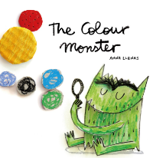  Main text – 3 weeks | 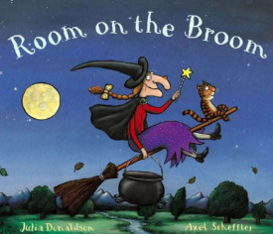  Main text – 3 weeks | Main text – 3 weeks  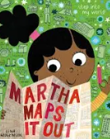 | 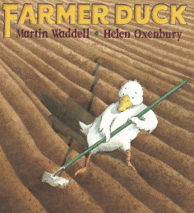  Main text – 2 weeks | 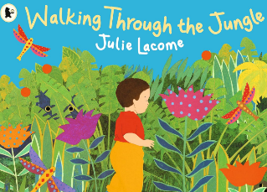  Main text – 3 weeks |   Main text – 3 weeks
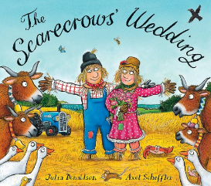  Main text – 3 weeks |   Main text – 3 weeks | 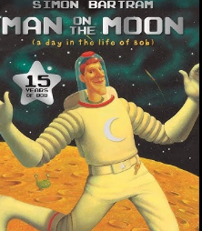  Main text – 3 weeks | 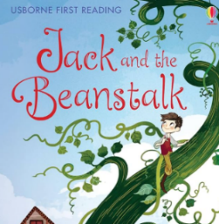  Main text – 3 weeks | 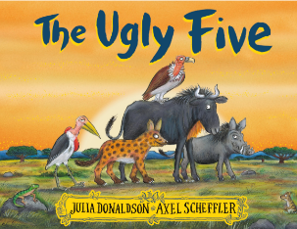  Main text – 3 weeks | 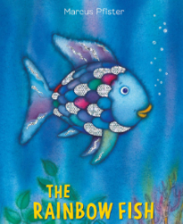  Main text – 3 weeks
Supplement texts  We are family  A superpower like mine  Find your happy  We’re going on a leaf hunt  The colour monster goes to school | Supplement texts  Room on the broom  The best Diwali ever  The stickman  Owl babies  The Nativity story | Supplement texts  Whatever next  The naughty bus  Mr Grumpy’s outing  Emma Jane’s aeroplane | Supplement texts  From seed to sunflower  Lola plants a garden  That’s not my leaf | Supplement texts  Giraffes can’t dance  Handa’s surprise  The very hungry  caterpillar  The dance of the  dinosaurs | Supplement texts  Sharing a shell  Pirates love underpants  Look what I found at  the seaside
Phonics  Little Wandle  Phase 2 CVC | Phonics  Little Wandle  Phase 2 CVC and tricky words | Phonics  Little Wandle  Phase 3 and tricky words  dictate words in books | Phonics  Little Wandle  Phase 3 and tricky words  begin to dictate sentences | Phonics  Little Wandle  Phase 4 and tricky words  Dictate sentences | Phonics  Little Wandle  Phase 4 and tricky words  Dictate sentences successfully
Handwriting  Letterjoin  Circles, spirals, lines and diagonals, jellies and zigzags, loopies and waves | Handwriting  Letterjoin  i, l and t  u, w and e  c and o | Handwriting  Letterjoin  n, m and h  j and y  g and q | Handwriting  Letterjoin  b, p and k  v, s and r | Handwriting  Letterjoin  f, x and z  All letters | Handwriting  Letterjoin  Lower and capitals
Writing opportunities  Baseline  Write initial sounds  Write a group of letters  Start to write first name | Writing opportunities  Write first name independently  Write captions and labels | Writing opportunities  Write first name with correct formation  Begin to write I can see sentences | Writing opportunities  Begin to write full name  Orally rehearse what  they’re writing  Write some tricky words  Write simple sentences  that the child can read  Write words with  digraphs and trigraphs | Writing opportunities  Write full name independently  Write a range of simple  repetitive sentences  Write simple sentences  that can be read by  others  Spell tricky words  Begin to form all lower  case letters correctly | Writing opportunities  Write full name with correct formation  Write recognisable letters, most of which are correctly formed Writes phonetically plausible words Writes a range of simple sentences independently that can be read by others

