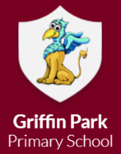

Year 2

Spring Term 1 2026

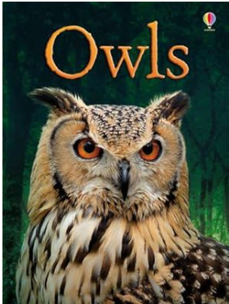

Welcome to year 2

Glossary
Below are the key words your child will be using in class this half term.
Please help your child to complete the glossary and be able to use and spell the words.
Please feel free to add any additional topic related vocabulary that you can think of.

Word | Definition
Non-chronological report
Plague
Bubonic
Oceans
Continents
Landmarks
Offspring

Over the next half term, your child will be
Working on:
Non-fiction – Incredible Owls
Money, Multiplication and division
Learning about animal and their offspring, basic needs for survival and the suitability of materials.
Learning about the Plague.
Looking at the food in DT.
Learning about oceans and continents and landmarks in London.

Your child needs your help and involvement! Please get involved by:
• Discussing the new vocabulary with your child.
• Regularly practising times tables. (Children receive a badge and certificate when they remember a set of times table facts e.g. 2 times table and division facts)
• Regularly practising spellings
• Encouraging your child to do some reading for at least 5 minutes every day, independently or to an adult.
Routines
PE: Indoor PE will take place on a Thursday and outdoor PE will be on Friday.

Homework
Reading | Try to listen to you child read a little each day. Books will be changed every Monday, Wednesday and Friday. Please remember to sign diaries.
Homework log | Complete homework in green homework log book to earn house points and tickets. These will need to be returned on Thursday, for new homework tasks to be given again on Friday.
Spellings/maths facts | Spellings/maths facts will be sent home on Friday and children will be tested the following Friday. Please remember to return spellings/maths facts book for new ones to be stuck in.
Library | Library books will be changed every Tuesday.

