

DATES FOR YOUR DIARY
10th October:
World Mental Health Day
16th October:
Developmental Language Disorder Day
20th October
Pumpkin Party
23rd October
Half term starts and we return on Tuesday 3rd November.
8th December
Christmas Jumper and Christmas Dinner Day
18th December
Awards assembly @ 1:15pm
18th December
School closes at 2pm and we return on Tuesday 5th January.

Griffin Park Primary School
SEND Newsletter
Autumn Term 2026
.

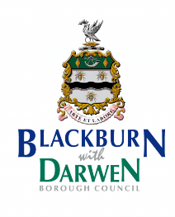
SENDCO
Mrs Tones is due back after the half term and will resume her SENCO Role when she’s back on 3rd November.

Parent and Carer Forum (volunteer group to support parents of children with SEND) All parents and carers are welcome to contact the forum for a chat, an opportunity to talk to other parents of children with SEND. They have regular coffee mornings too! Please feel free to email: bwdparentcarerforum@ gmail.com
Blackburn's SEND Local Offer
The Local Offer is the central information point for families with children and young people aged up 25 years with special educational needs and/or disabilities. They have lots of information about help available.
https://blackburn.gov.uk/children-families-and-young-people/special-educational-needs-and-disabilities-send-local-offer
Family Autism Service
A partnership project with Child Action Northwest and Spring North, offering support for families across East Lancashire with children up to the age of 25, seeking or with an autism diagnosis. The objective of the program is to offer support to parents/carers with the focus on two key areas of support: education on autism and strategies to support.
Email: autism@canw.org.uk
Call: 01254 244706

I hope the children have all settled into their new classes and have had a positive start to the new school year. It really is a shock coming back for everyone, but we soon get back into the swing of things. The termly newsletters will provide some advice, local events, information and key dates for your diary.

