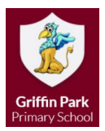

Reception
Autumn 1
This half term we will be focusing on Ourselves. We will do work around colours, feelings, families and homes. We will move onto Autumn and harvest, finishing the half term on a spooky note.
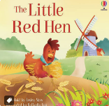
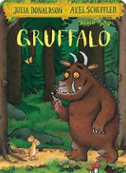
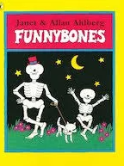
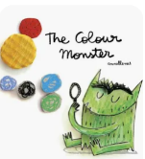
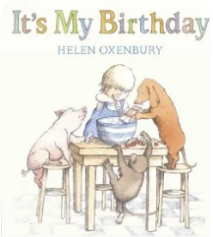

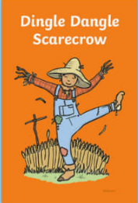
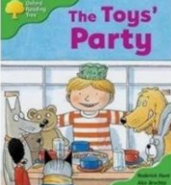
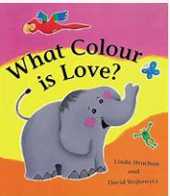

You can support your child by using the words in the glossary at home.
happy | Autumn | heavy heavier
sad | harvest | light lighter
angry | fruit | balance
scared | vegetable | long longer
calm | tractor | short shorter
special | combine harvester | tall taller tallest
favourite | ingredients | match
skeleton | habitat | pattern

Our topic begins with a focus on ourselves and how we feel – reading and writing our name, making portraits in paint, collage, felt tips, chalk and crayons.
We will be celebrating how all children are different, but might have features, likes, and other things in common; how they are special and what is special to them.
PE kits need to stay in school (black shorts, white t-shirt and black pumps).
Reading books will come home once we have started teaching phonics and will initially have no words, enabling lots of chance for talk and discussion.



You can help at home by:
- Sharing stories with your child
- Singing nursery rhymes and other songs together
- Comparing the size of objects in the home using the language suggested in our glossary
- Supporting your child in writing their name
- Talking about when your child is angry and how they can express their anger safely
- Going on walks and looking for signs of Autumn

