Reception Long Term Overview
2026-27 | Autumn 1 | Autumn 2 | Spring 1 | Spring 2 | Summer 1 | Summer 2
Theme | All About Me | Seasonal Celebrations | Transport/  People Who Help Us | Growing | Animals  and Insects | Animals  Land and Sea
Communication and language  Children engage in stories, songs, rhymes, poems and non-fiction texts. | 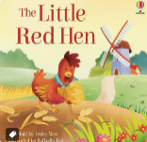  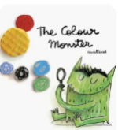  Six dinner Sid  Gruffalo  Funny bones  Rosie’s Walk  Non- fiction – All about me  Rhyme | 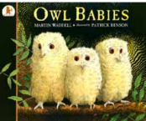  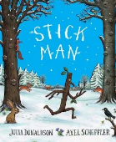  Can’t you sleep little bear  Laura’s star  All About Weather  The Nativity Story | 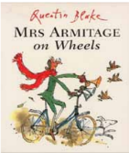  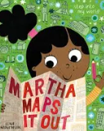  Whatever Next  Aliens love underpants  Mrs Armitage on wheels  Mr Gumpy’s Outing | 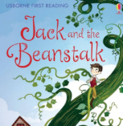  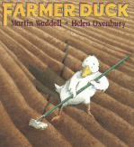  Pigs might fly  SHHH!  On the way home | 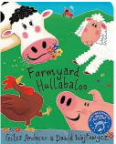  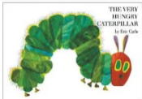  The Bad Tempered Ladybird  Farmyard Hullabaloo | 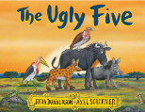  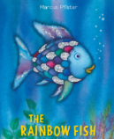  Handa’s surprise  The Dance of the Dinosaurs  Penguins
Personal, social and emotional development | Me and my relationships  All about me  What makes me special?  Me and my special people  My feelings  Routines  Building relationships  Following rules  Healthy teeth | Valuing Difference  I’m special You’re special  Same and different  I am caring  I am a friend  Changing into PE kit  Healthy teeth  Hygiene | Keeping Safe  What is safe for my body  Medicines  Safe online  People who keep me safe  Listening to my feelings  Safety indoors and outdoors  Hygiene | Growing and Changing  Seasons  Life stages – plants – animals- humans  Getting bigger  Me and my body – girls and boys  Hygiene | Rights and Respect  Looking after my special people  Caring for our world  Looking after money | Being my best  Building resilience  Yes, I can!  Healthy eating  My healthy mind  A good night’s sleep  Move your body
Physical development | Gross motor  Ball games  Gymnastics  Travel around, under, over and through balancing and climbing equipment  Fine motor  Dominant hand  Dough disco  Unit 1: Patterns | Gross motor  Developing spacial awareness  Bikes/scooters  Fine motor  Dough disco  Unit 1: Patterns  Good posture for sitting  Pencil grip | Gross motor  Ball games  Underhand rolling  Balance boards  Fine motor  Good posture for sitting  Letter formation  Directionality  Unit 1: | Gross motor  Dance: Copying and repeating  Fine motor  Good posture for sitting  Letter formation  Directionality  Pencil grip | Gross motor  Dance: mirror and match a partner  Experiment with different ways of moving  Fine motor  Letter formation  Directionality | Gross motor  Athletics  Running  Travelling  Catching  Sports day  Fine motor  Letter formation  Directionality  Pencil grip
Literacy | Baseline  Phase 2 Phonics  s a t p, i n m d, g o c k, ck e u r, h b f l  Guided reading  labelling  Name writing Shopping lists  Writing initial sounds simple captions  Phase words  Sequencing | Extending vocabulary  Phase 2 phonics  ff ll ss j, v w x y, z zz qu ch, sh th ng nk  Guided reading  Recount  Name writing  Labelling  Story scribing  Retelling stories Orally  Letter writing | Extending vocabulary  Phase 3 phonics  ai ee igh oa, oo oo ar or, ur ow oi ear, air er words with double letters: dd mm tt bb rr gg pp ff  Exciting adjectives ‘Wow words’ Rhyming words/sentences Instructions Captions Writing recipes, lists Phase words | Extending vocabulary  Review Phase 3  words with two or more digraphs  words ending in –ing compound words  words ending –s words with –es at end /z/  Creating own story maps Writing captions and labels Writing simple sentences Writing short sentences to accompany story maps | Extending vocabulary  Phase 4  short vowels CVCC CCVC  longer words compound words  n: –ing, –ed /t/, –ed /id/ /ed/ –est  Labels and captions – life cycles  Beginning to use finger spaces Form lower-case and capital letters correctly Rhyming words Recount – A trip to the farm Acrostic poems | Extending vocabulary  Review Phase 4  short vowels CCVCC CCCVC CCCVCC longer words  Story writing  Writing sentences using a range of tricky words that are spelt correctly Innovation of familiar texts  Using familiar texts as a model for writing own stories  Character description –sea creatures
Mathematics | Baseline – Getting to know you  Match , sort and Compare  Talk about measure and patterns  It’s me 1,2, | Shape: Circles and triangles  Exploring numbers – 1-5  Composition of number  Shapes with 4 sides | Alive in 5  Mass and Capacity  Growing 6, 7, 8  Composition of number  Length, height and time | Building 9 and 10  Composition of number  Exploring 3D shapes | To 20 and beyond  How many now?  Manipulate, compose, decompose | Sharing and grouping  Visualise, build and map  Make connections
Understanding the world | Something special to me  Body parts/ Senses  Autumn (seasons)  RE: Harvest: Why do people of faith say thank you to God at Harvest time?  What is our school like?  Where do we live?  Seasons Autumn  Animals hibernating | RE: Christmas  Diwali  Bonfire Night  Day and Night  Seasons: signs of Autumn  Nocturnal animals  Computing: how do they help us? | People who help us, our community  Fire brigade, police, Doctor, Dentist (visits)  Chinese New Year  Maps : Cody the Car  Seasons Winter  Computing: Programming and simple instructions  RE: World Faith Hinduism | Life cycles  How much have I grown?  Growth  chicks  RE: Easter  Seasons Spring  Computing: Key boards and mouse | Life cycle of a butterfly,  Animals- Pets /farm  Mini-beasts  Habitats  Floating and sinking  Seasons – Spring/summer  Computing: Digital music  RE: World Faith Islam | Dinosaurs  What do they eat?  Palaeontologist- Mary Anning  Animals Around the world  Grouping animals  Barnaby bear – Journeys/maps/ comparing localities. (Africa)  Computing: photographs  RE: World Faith Islam and Hinduism
Expressive art and design | Naming colours  Portraits  Singing simple songs from  Memory  Perform a song (Harvest)  Role-play/props/puppets  Music: Exploring sound  Art/Design: Marvellous marks | Colour mixing, Pattern  Texture  Den making  Printing  Role-  play/props/puppets  Perform a story  Music:  Art/Design: Paint my world | Observational drawings  Models Choosing / selecting own resources  Role-play/props/puppets  Music:  Art/Design: Creation station | Paper Mache  Printing  Clay animals  Role-play/props/puppets  Perform a song  Music:  Art/Design: Let’s get crafty | making Collage – Megan Coyle  Mask making  Role-play/props/puppets  Perform a story  Music:  Art/Design: seasonal crafts | Painting and drawing emotions  Role-play/props/puppets  Music:

